 | Home Reading Question Prompts
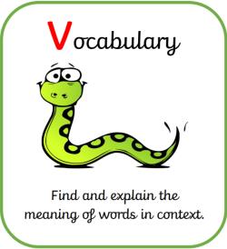 | What do the words ___________and ___________ suggest about the character/ setting /mood?  Find one word in the text which means ___________  Which word tells you that ___________?  Why did the author use the word ___________ to describe ___________?  How has the author’s choice of words created the feeling of ___________?
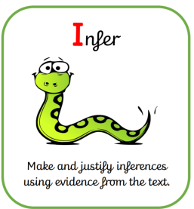 | What impression of ..... do you get from these paragraphs?  How was ___________ different after ___________? Why?  Why did the character behave like this?  Why do you think (s)he ___________?  What do they seem to think about each other?  Can we work out how ___________ feels about ___________?  Why do you think ___________ tells ___________?  What does ___________ think?  How did ___________ react?
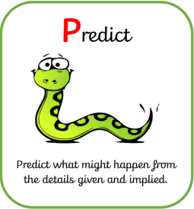 | Who is on the front cover? What is in the background? How might these details give us clues about the content of the book?  Based on what you’ve read so far… what do you think will happen next?  How might this story end?  Do you think the character will change his/her behaviour in the future?  What do you think the character do next? What would you do? Why?  What do you think is likely to happen when ___________?  What could ___________?  What might happen if ___________?
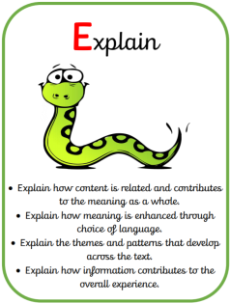 | How does the author make their writing interesting to read?  Why is the text arranged in this way?  Which bit was the most interesting or exciting?  How has the character changed throughout the story?  How do diagrams, photographs or illustrations help us to enjoy/understand the text?  How has the choice of words created a feeling of ___________?
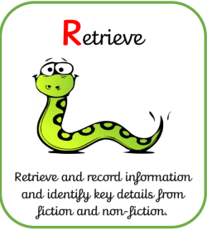 | How did…? How often…? Who had…? Who is…? Who did…? What happened to…? Whose perspective is the story told from?  What did (s)he/it look like?  Find a word or phrase which tells us how the character is feeling.  Which bit tells us ___________?  Where does the story take place?  Who was (s)he/it?   Ask your child to find the bit in the text and point to it to answer these questions.
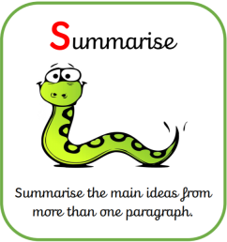 | What is the main message in this paragraph?  Can you describe what has happened in this paragraph/chapter?  Why do you think that might be important?  Is there anything you know now which you didn’t know before?  What sticks most in your mind about ___________?  What moment do you remember most from ___________?

